***The Harry Potter Series***

***A Magical Journey Beyond Imagination***

**Prepared by:** Fatima Ahmed  
**Date:** October 2025

Contents

**Introduction** 1

Storyline Overview 2

Major Characters 3

Themes and Symbolism 3

Legacy and Cultural Impact 4

Conclusion 4

References (APA 7th Edition) 4

# **Introduction**

The *Harry Potter* series is one of the most remarkable and influential literary works in modern history. Written by British author **J.K. Rowling**, the seven fantasy novels follow the life and adventures of a young wizard, *Harry Potter*, and his journey from childhood to adulthood in a magical world hidden within ordinary society.

The story begins with *Harry Potter and the Philosopher’s Stone* (also published as *The Sorcerer’s Stone* in the United States) and concludes with *Harry Potter and the Deathly Hallows* (Rowling, 1997–2007). These books, published between 1997 and 2007, have sold more than **500 million copies worldwide**, making them the **best-selling book series in history** (Statista, 2023).

Translated into over **80 languages**, the series not only captivated readers but also gave rise to one of the most successful film franchises of all time. The central theme revolves around *friendship, love, bravery, and the eternal battle between good and evil*. Through Harry’s experiences, readers witness the struggles of growing up, discovering one’s identity, and making moral choices.

*(Image: A picture of J.K. Rowling with the first Harry Potter book can be placed here.)*

# Storyline Overview

The story begins with *Harry Potter*, an orphaned boy who lives a miserable life with his cruel relatives, the Dursleys. On his **eleventh birthday**, he learns that he is a wizard and receives an invitation to attend **Hogwarts School of Witchcraft and Wizardry**. There, Harry discovers the truth about his parents — that they were killed by the dark wizard **Lord Voldemort**, and that Harry mysteriously survived the deadly curse that killed them (Rowling, 1997).

Each book in the series represents a new school year at Hogwarts, where Harry learns spells, makes lifelong friends like **Ron Weasley** and **Hermione Granger**, and uncovers dark secrets about the wizarding world. As the story unfolds, Harry’s destiny becomes clearer — he is the one chosen to defeat Voldemort, whose power continues to grow in secret.

The narrative builds to the final book, *Harry Potter and the Deathly Hallows*, where Harry and his friends leave Hogwarts to find and destroy Voldemort’s Horcruxes — magical objects containing pieces of his soul. The series reaches its climax with the **Battle of Hogwarts**, symbolizing the triumph of love, courage, and unity over fear and evil.

*(Image:* 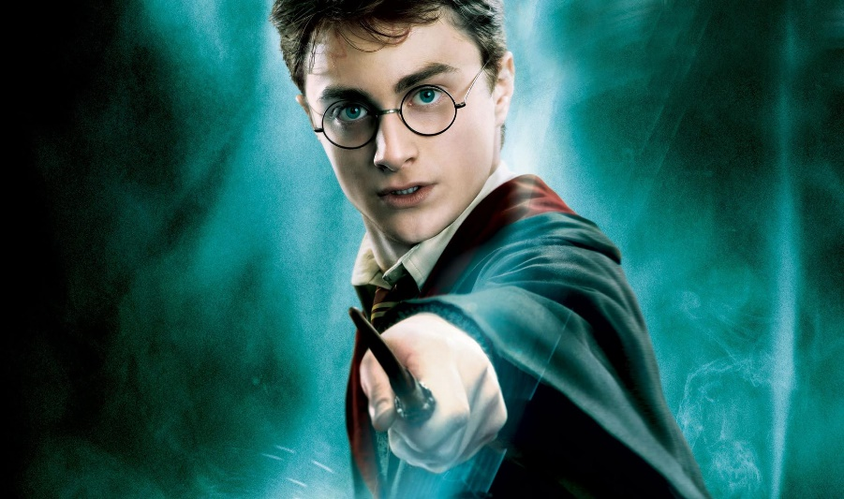

# Major Characters

The series features a wide range of memorable characters, each with unique qualities and emotional depth:

* **Harry Potter** – The protagonist, brave and compassionate, who symbolizes hope and perseverance.
* **Hermione Granger** – Intelligent and determined, Hermione represents wisdom, logic, and loyalty.
* **Ron Weasley** – Harry’s best friend, known for his humor, bravery, and strong sense of loyalty.
* **Albus Dumbledore** – The wise and kind headmaster of Hogwarts, a mentor to Harry.
* **Lord Voldemort (Tom Riddle)** – The main antagonist, obsessed with power and immortality, representing ultimate evil.
* **Severus Snape** – A complex and tragic character whose true loyalty and sacrifice are revealed only at the end.

These characters reflect the diversity of human emotion — love, fear, jealousy, courage, and redemption — which makes the story deeply relatable even in a magical setting.

*(Image:* 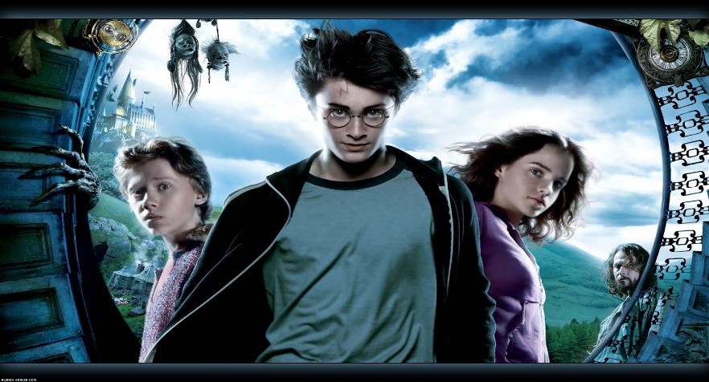

## Themes and Symbolism

The *Harry Potter* series is not just a fantasy adventure; it explores deep themes that resonate with readers of all ages:

* **Good vs. Evil:** The conflict between Harry and Voldemort mirrors the timeless struggle between light and darkness.
* **Love and Sacrifice:** Rowling portrays love as the most powerful magic of all — the force that protects Harry and ultimately defeats evil (Rowling, 1997).
* **Friendship and Loyalty:** The unbreakable bond between Harry, Ron, and Hermione shows that true friendship can overcome any obstacle.
* **Courage and Identity:** The story emphasizes that real bravery lies in making the right choices, not in the absence of fear.
* **Prejudice and Social Injustice:** Through subplots like the mistreatment of house-elves and “Muggle-born” discrimination, Rowling comments on racism and inequality in the real world (Granger, 2018).

These themes give the series its emotional power and moral depth, making it far more than just a story about wizards and spells.

# Legacy and Cultural Impact

The legacy of *Harry Potter* extends far beyond books and movies. It redefined children’s literature, encouraged millions of young people to read, and inspired countless writers and creators. The **film adaptations** by **Warner Bros.** became one of the **highest-grossing movie franchises in history**, grossing over $7 billion worldwide (Box Office Mojo, 2023).

The wizarding world continues to thrive through spin-offs like *Fantastic Beasts*, theme parks, merchandise, fan communities, and online platforms. Phrases like *“Muggle”*, *“Hogwarts”*, and *“Quidditch”* have become a part of popular culture.

Beyond entertainment, the story teaches timeless lessons about love, unity, and the courage to stand up against injustice. As **J.K. Rowling** beautifully said:

“Whether you come back by page or by the big screen, Hogwarts will always be there to welcome you home.”

# Conclusion

The *Harry Potter* series is more than a literary phenomenon — it’s a global symbol of imagination, resilience, and moral strength. Through its characters and themes, it encourages readers to believe in goodness, embrace differences, and find courage in the darkest times.

Even decades after its release, the story of Harry Potter continues to inspire and unite people across generations and cultures — proving that magic truly exists in the power of storytelling.

# References (APA 7th Edition)

* Box Office Mojo. (2023). *Harry Potter Franchise*. <https://www.boxofficemojo.com/franchise/fr158618009/>
* Granger, J. (2018). *The Hidden Key to Harry Potter: Understanding the Meaning, Genius, and Popularity of Joanne Rowling’s Harry Potter Novels.* Zossima Press.
* Rowling, J. K. (1997–2007). *Harry Potter Series.* Bloomsbury Publishing.
* Statista. (2023). *Best-selling book series worldwide.* <https://www.statista.com/statistics/273644/most-popular-book-series-worldwide/>